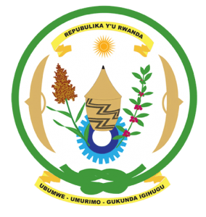
28th Session of the Universal Periodic Review Working Group
Review of Switzerland
09th November 2017

Statement by Rwanda delivered by Mr. Moses Rugema
- Rwanda warmly welcomes the delegation of Switzerland and thanks them for the presentation of their national report and the oral update just provided.
- Rwanda welcomes Switzerland’s continued efforts to promote and protect human rights including through implementation of the recommendations and voluntary commitments of its second cycle UPR.
- We welcome Switzerland’s efforts to combat discrimination, hate speech and related intolerance. We have one question and one recommendation:
- As part of Switzerland’s efforts to prevent mass atrocities worldwide including through the GAAMAC network, to what extent has Switzerland undertaken an assessment of potential risk factors of atrocity crimes in Switzerland with a view to their prevention?
- We recommend that; Switzerland include in its next UPR report, information on measures it has taken to implement article 261 bis of its criminal code in particular on combating denial, trivialisation or attempts to justify genocide or other crimes against humanity.
We wish Switzerland every success in the implementation of the recommendations of this UPR.
Thank you

