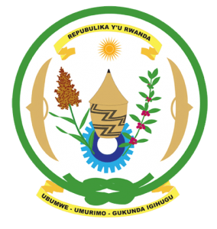
28th Session of the Universal Periodic Review Working Group
Review of Ghana
7th November 2017
Statement by Rwanda delivered by Mr. Moses Rugema

Thank you Mr. President
- Rwanda warmly welcomes the delegation of Ghana and thanks them for the presentation of their national report and the update just provided.
- Rwanda welcomes the many positive steps taken by Ghana to promote human rights in Ghana and strengthen the institutional framework for the promotion and protection of human rights. We welcome Ghana’s ratification of the first and second optional protocols of the CRC and the implementation of various legislative and policy measures to improve the economic and social well-being of its citizens.
- While welcoming numerous efforts to promote women’s rights and to fight sexual and gender-based violence, we encourage Ghana to enhance those efforts including through the implementation of relevant laws to ensure justice for victims.

Rwanda recommends that Ghana:
- Intensifies its efforts towards abolishing the death penalty including through holding public consultations and a referendum on its abolition in accordance with Ghana’s constitution.
- Strengthen implementation of legislation and policies aimed at ending harmful traditional practices in particular child, early and forced marriage.

We wish Ghana every success in their review. Thank you.

