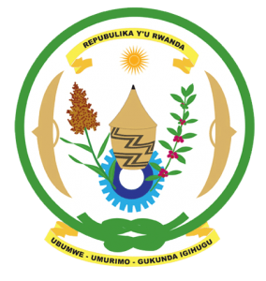
28th Session of the Universal Periodic Review Working Group
Review of Gabon
07th November 2017
Statement by Rwanda delivered by Mr. Moses Rugema

Thank you Mr. President,
- Rwanda warmly welcomes the delegation of Gabon and thanks them for the presentation of their national report and the update just provided.
- Rwanda commends Gabon for its continued efforts to promote and protect the human rights of its people. We particularly commend Gabon for the notable progress it has registered in improving the social and economic status of its citizens.
- Rwanda welcomes Gabon’s ratification of the Second Optional Protocol to the ICCPR on the Abolition of the Death Penalty and the Optional Protocol to the Convention on the Rights of Persons with Disabilities.
Rwanda recommends that Gabon:
- Expedite its efforts to establish an independent national human rights institution in accordance with the Paris Principles.
- Enhance efforts to implement the National Strategy on Gender Equality and Equity including addressing the under-representation of women in decision-making bodies and elimination of harmful traditional practices.
We wish Gabon every success in the implementation of the recommendations of this UPR.
Thank you

