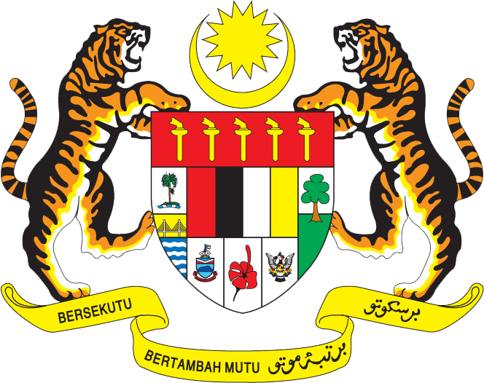

Statement by Kalpana Devi
Permanent Mission of Malaysia to the United Nations Office at Geneva
and other International Organisations

Review of Zambia

28th Session of the UPR Working Group of the Human Rights Council
6 – 17 November 2017

Mr. President,

Malaysia welcomes the delegation of Zambia and we thank them for the presentation of their national report.

- Malaysia is pleased to note the advancements made by Zambia in the areas of environment, health, education, women’s rights and children.

- Malaysia commends Zambia’s Seventh National Development Plan (7NDP) under the theme: “Accelerating Development Efforts towards Vision 2030 without Leaving Anyone Behind”, that seeks to reduce poverty, vulnerability, inequalities, improve governance and enhance human development, among others. We also commend Zambia for its efforts to address gender based violence incidences in the country through the Anti-Gender–Based Violence Act. Furthermore, Malaysia believes that the establishment of shelters, One-Stop-Centre and Anti-Gender–Based Violence Fund are steps in the right direction to provide necessary support and protection to the victims of gender based violence.

- Malaysia wishes Zambia the best in its future undertakings for further progress in the field of human rights

Geneva
13 November 2017

