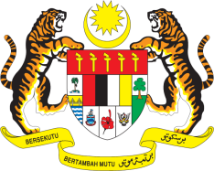

Statement by Mr. Syed Edwan Anwar, Minister Counselor
Permanent Mission of Malaysia to the United Nations Office at Geneva
and other International Organisations,

Review of Ukraine

28th Session of the UPR Working Group of the Human Rights Council
6 – 17 November 2017

Mr. President,

Malaysia welcomes the delegation of Ukraine and we thank them for the presentation of their national report.

- Malaysia commends Ukraine for its various efforts undertaken to promote and protect human rights in the country. We note that Ukraine has taken a number of significant steps to develop the legal and institutional frameworks to combat human trafficking, and we welcome the State Social Program for Combating Trafficking in Human Beings for the period until 2020. We also welcome the good partnership forged between the Government and civil society in implementing measures aimed at combating human trafficking. We are encouraged by the numerous awareness-raising and victim-support activities targeted at different segments of the society.

- In the spirit of constructive engagement, my delegation would like to propose to Ukraine the following recommendations:

  - intensify efforts to combat human trafficking and to provide adequate resources to increase the quality of services provided for victims of trafficking.

I thank you, Mr. President.

Geneva
15 November 2017

