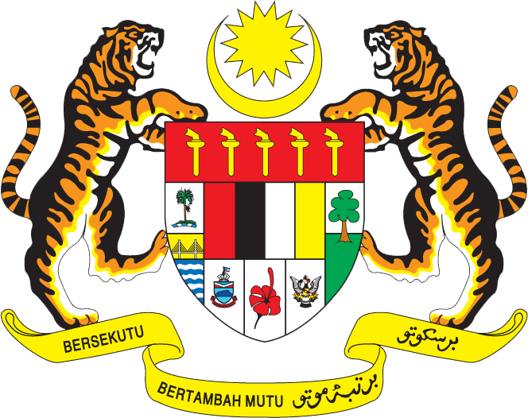

Statement by Kalpana Devi
Permanent Mission of Malaysia to the United Nations Office at Geneva
and other International Organisations

Review of Sri Lanka

28th Session of the UPR Working Group of the Human Rights Council
6 – 17 November 2017

Mr. Vice-President,

Malaysia welcomes the delegation of Sri Lanka and we thank them for the presentation of their national report.

- Malaysia welcomes the progress made in addressing Gender Based Violence (GBV) incidences in Sri Lanka, including through the operationalisation of a hotline to receive GBV complaints, amendments to the Domestic Violence Act to strengthen the legal response to domestic violence and also the establishment of the National Women’s Commission which is mandated to uphold women’s rights and investigate women’s rights violations. Malaysia also notes that Sri Lanka had adopted the National Action Plan to address GBV which is currently undergoing revision at the national level. We welcome this initiate and look forward to its full and effective implementation.

- In the spirit of constructive engagement, Malaysia would like to propose to Sri Lanka the following two recommendations:

  - One: to allocate adequate resources to ensure the continuous and effective implementation of the National Action Plan to address Gender Based Violence; and

  - Two: to continuously provide gender sensitive trainings to authorities handling Gender Based Violence cases.

I thank you, Mr. Vice-President.

Geneva
15 November 2017

