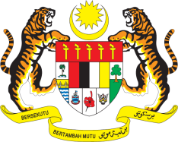

Statement by Kalpana Devi
Permanent Mission of Malaysia to the United Nations Office at Geneva
and other International Organisations

Review of the Republic of Korea

28th Session of the UPR Working Group of the Human Rights Council
6 – 17 November 2017
______________________________________________________________

Mr. President.

Malaysia welcomes the delegation of the Republic of Korea and we thank them for presentation of their national report.

- Malaysia welcomes, amongst others, the advancements made by the Republic of Korea in the areas of labour, social security, health, education, women’s rights, children and the protection of the rights of the minority.

3. Malaysia lauds the Republic of Korea for the various initiatives undertaken to promote the rights of older persons. Malaysia believes that programmes targeted at improving the social and economic well-being of older persons can pave the way for increased access to health and social services, as well as empowering communities to help and care for older persons. The introductions of programmes such as the basic pension scheme, elderly employment initiative, friendship projects and the establishment of infrastructure that serves as protection institutions and shelters for elder victims of abuse are encouraging and should be continued.

4. Malaysia wishes the Republic of Korea a successful UPR.

I thank you, Mr. President.

Geneva
9 November 2017

