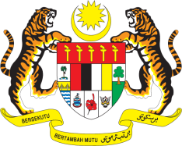

Statement by Malaysia
Permanent Mission of Malaysia to the United Nations Office at Geneva
and other International Organisations

Review of Peru

28th Session of the UPR Working Group of the Human Rights Council
6 – 17 November 2017

Mr. Vice-President.

Malaysia welcomes the delegation of Peru and we thank them for presentation of their national report.

- Malaysia is encouraged by Peru’s continuous efforts to further promote and protect human rights and is pleased with the significant advancements made in promoting the rights of the indigenous people, persons with disabilities, women and children and in promoting education.

- We welcome the 2015 National Policy for Mainstreaming an Intercultural Approach, and the progress made on the rights of people of African descent, such as the establishment of the National Development Plan for the Afro-Peruvian Population 2016-2020, the National Afro-Peruvian Council and the working group on policies for Afro-Peruvians.

- Malaysia wishes Peru a successful UPR.

I thank you, Mr. President.

Geneva
8 November 2017

