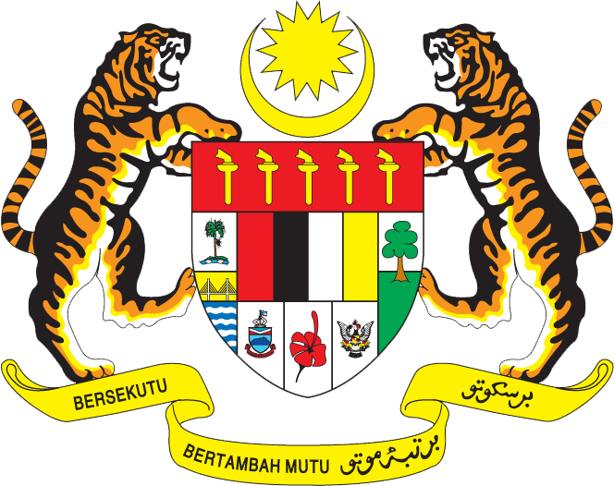

Statement by Mr. Syed Edwan Anwar, Minister Counselor
Permanent Mission of Malaysia to the United Nations Office at Geneva
and other International Organisations,

Review of Pakistan

28th Session of the UPR Working Group of the Human Rights Council
6 – 17 November 2017

Mr. President,

Malaysia welcomes the delegation of Pakistan and we thank them for presentation of their national report.

- Malaysia applauds Pakistan for the great strides it has achieved in promoting and protecting human rights since its second cycle UPR review in 2012. We laud the efforts by Pakistan to establish the necessary social, legal, and physical infrastructure for change and transformation through its Vision 2025 and the establishment of the National Commission on Human Rights in 2012 and the Ministry of Human Rights in 2015.

- We also note that Pakistan is taking efforts to further enhance its maternal and neo-natal healthcare services, promoting food security as well as pursuing strategies related to improving nutrition as well as alleviating poverty. Malaysia is also pleased to note that human rights are being mainstreamed into development planning as part of wider efforts to promote the right to development.

- In the spirit of constructive engagement, my delegation would like to propose to Pakistan the following two recommendations:

  - One: continue to promote human rights education, training and awareness raising; and

  - Two: expand further ongoing efforts to provide medical facilities and access to vulnerable groups, particularly women and girls, in rural areas, as part of overall efforts to achieve universal health coverage in Pakistan.

I thank you, Mr. President.

GENEVA
13 November 2017

