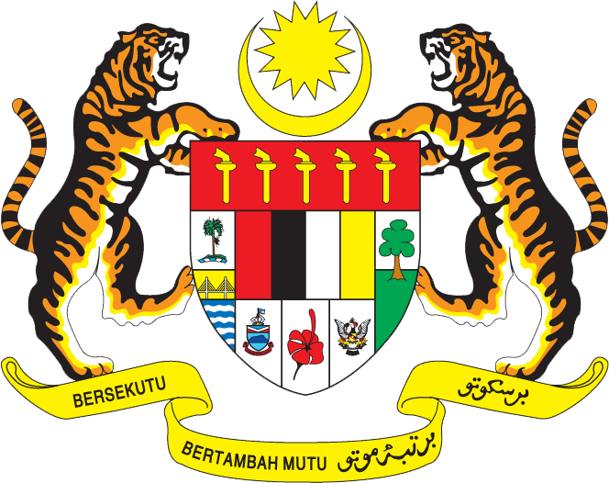

Statement by Mr. Syed Edwan Anwar, Minister Conselor
Permanent Mission of Malaysia to the United Nations Office at Geneva
and other International Organisations,

Review of Ghana

28th Session of the UPR Working Group of the Human Rights Council
6 – 17 November 2017

Mr. President.

Malaysia welcomes the delegation of Ghana and we thank them for presentation of their national report.

- Malaysia is pleased to note that Ghana has made enhancing the role of women in the country as a key human rights priority in the country. Women have played an increasingly politically active role in Ghana, with 37 women elected to the Parliament of Ghana in the 2016 elections. Ghana’s Ministry of Gender, Children and Social Protection (MoGCSP) has also successfully led efforts to promote gender mainstreaming and equality through its work with Government agencies and other stakeholders the country.

- We commend the comprehensive long-term efforts of Ghana to improve access to education and address poverty through such programmes as the Free Compulsory Basic Education (fCUBE) and Livelihood Empowerment against Poverty (LEAP) initiative, that ensures that senior secondary school education remains free and the provision of free school uniforms. We note positively that school enrolments have improved following the provision of one hot meal per day to more than 1.6 million schoolchildren in 216 districts in the country.

I thank you, Mr. President.

GENEVA
7 November 2017

