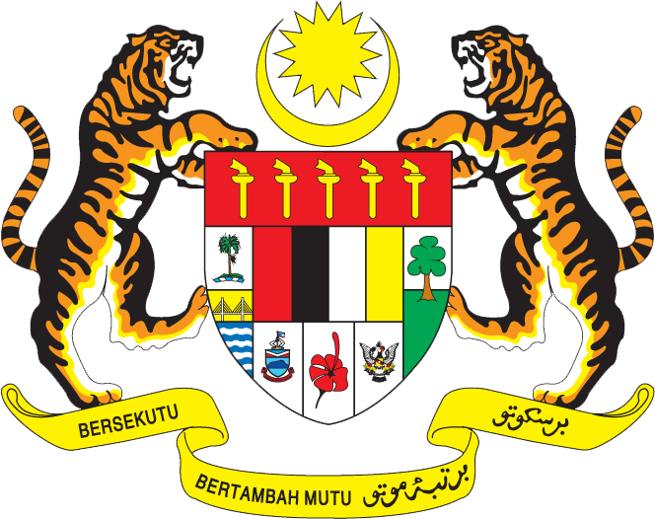

Statement by Malaysia
Permanent Mission of Malaysia to the United Nations Office at Geneva
and other International Organisations

Review of Gabon

28th Session of the UPR Working Group of the Human Rights Council
6 – 17 November 2017

Mr. Vice-President.

Malaysia welcomes the delegation of Gabon and we thank them for presentation of their national report.

- Malaysia is pleased to note the significant progress made in the areas of health, education, empowerment of women, children and human development. Malaysia welcomes the commitment of the Government of Gabon to uphold the right to health, demonstrated through the development and the adoption of the 2006-2015 National Policy on Health and Reproduction, the 2011-2015 National Plan for Sanitary Development and the 2008-2015 National Strategic Plan to Combat HIV/AIDS.

- We commend efforts aimed at providing information, education, and sexual and reproductive health services in the prevention of new HIV infections. We also welcome the Government’s initiative to provide all persons living with HIV access to free antiretroviral treatment and all HIV-positive pregnant women to free prenatal care and delivery services. Nonetheless, we note with concern the comments by the CEDAW and CRC Committees on the disproportionately high number of women living with HIV/AIDS, the high rate of mother-to-child transmission of HIV, and the limited availability of HIV/AIDS-related services.

4. Malaysia wishes Gabon a successful UPR.

I thank you, Mr. Vice-President.

Geneva
7 November 2017

