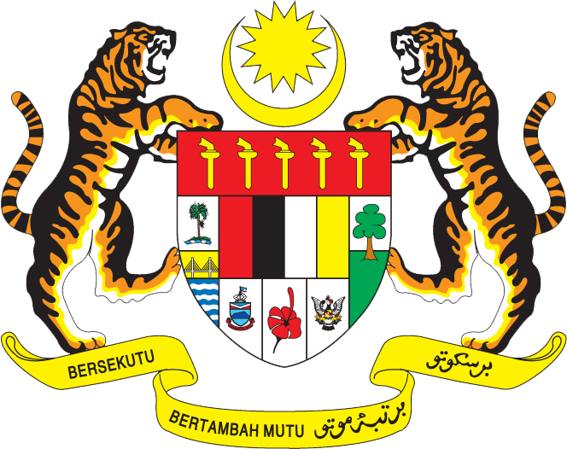

Statement by Malaysia
Permanent Mission of Malaysia to the United Nations Office at Geneva
and other International Organisations,

Review of Czech Republic

28th Session of the UPR Working Group of the Human Rights Council
6 – 17 November 2017

Mr. President,

Malaysia welcomes the delegation of Czech Republic and we thank them for presentation of their national report.

- Malaysia is encouraged to note that Czech Republic has continued to demonstrate its commitment to the promotion and protection of human rights. Malaysia acknowledges the various efforts undertaken by the Government of Czech Republic since its last review in 2012, including by ensuring domestic legal frameworks are in place to fulfil its international human rights obligations. We welcome the positive developments made in the area of social inclusion and protection of the rights of the vulnerable groups, and look forward to the effective implementation of the 2014 Social Inclusion Strategy, the Strategy for Combating Social Exclusion 2016-2020, the National Action Plan for Positive Ageing 2013-2017 and the National Action Plan to Promote Equal Opportunities for the Persons with Disabilities 2015–2020.

- In the spirit of constructive engagement, my delegation would like to propose to Czech Republic the following recommendation:

3.1 To ratify the Optional Protocol to the Convention on the Rights of Persons with Disabilities by the end of 2017, consistent with the National Plan for the Promotion of Equal Opportunities for Persons with Disabilities 2015–2020.

I thank you, Mr. President.

Geneva
6 November 2017

