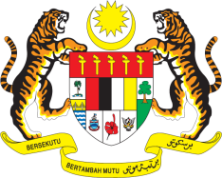

Statement by Malaysia
Permanent Mission of Malaysia to the United Nations Office at Geneva
and other International Organisations

Review of Benin

28th Session of the UPR Working Group of the Human Rights Council
6 – 17 November 2017

Mr. Vice-President.

Malaysia welcomes the delegation of Benin and we thank them for presentation of their national report.

- Malaysia is pleased to note the efforts undertaken by Benin in the promotion and protection of human rights and fundamental freedoms for all. We welcome Benin’s initiative to streamline national legislation with international standards through the adoption of various laws and human rights policies, and we also welcome the advancements made in the field of health, education, women’s rights, children, housing and land management. Malaysia commends Benin’s new policy on social protection and access to basic social services. We note the observation made by the Committee on the Rights of the Child pertaining to the infant, neonatal and maternal mortality rates, which remain very high.

3. In the spirit of constructive engagement, my delegation would like to propose to Benin the following recommendation:

3.1 Increase efforts to reduce infant, neonatal and maternal mortality, through systematic prevention and treatment mechanisms and accessible maternal and infant healthcare services.

I thank you, Mr. President.

Geneva
10 November 2017

