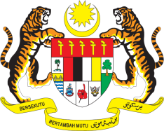

Statement by Malaysia
Permanent Mission of Malaysia to the United Nations Office at Geneva
and other International Organisations

Review of Argentina

28th Session of the UPR Working Group of the Human Rights Council
6 – 17 November 2017
______________________________________________________________

Mr. Vice-President,

Malaysia welcomes the delegation of Argentina and we thank them for presentation of their national report.

2. Malaysia is pleased to note that the Government of Argentina has undertaken various measures in the promotion and protection of human rights and fundamental freedoms for all. Malaysia welcomes the adoption of Argentina’s first National Action Plan for the Prevention and Eradication of Violence against Women and Assistance to Victims (2017-2019). At the same time, Malaysia recognises that Argentina faces challenges that could hinder its efforts in addressing violence against women, such as coordination between Federal and Provincial Governments, and lack of safe shelters for women victims of gender-based violence.

3. In the spirit of constructive engagement, Malaysia would like to propose to Argentina the following two recommendations:

3.1 One: continue efforts to strengthen the implementation of legislation on violence against women; and

3.2 Two: further strengthen the legal provisions and social protection mechanisms to effectively protect women who are victims of domestic violence.

I thank you, Mr. Vice-President.

Geneva
6 November 2017

