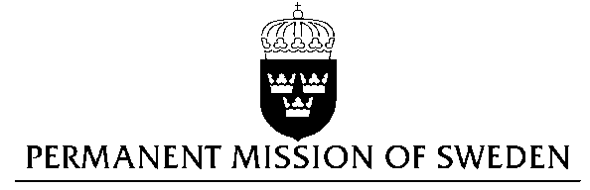
UN Human Rights Council

UPR 28th session

Statement by Sweden in the interactive dialogue on Zambia

Delivered by Counsellor Anna Envall
Geneva, 13 November 2017 (speaking time 1.35)

Mr President,

Sweden wishes to welcome the delegation of Zambia and extends its thanks for the report and the presentation. Sweden acknowledges the continued work of the Government of Zambia to fulfil its obligations with regard to human rights and encourages further efforts.

Sweden recommends the Government of Zambia to:

- ensure that necessary reforms are undertaken to guarantee the effective protection of the rights to freedom of expression, assembly and association. This includes enacting without delay an expanded Bill of Rights and Access to Information Bill and ensuring that the Public Order Act is implemented objectively and with professionality by the police,

- decriminalize same-sex relationships between consenting adults,

- ratify the second Optional Protocol to the ICCPR and to abolish the death penalty.

I thank you Mr. President

