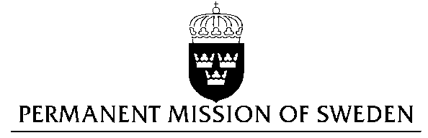
UN Human Rights Council

UPR 28th session

Statement by Sweden in the interactive dialogue on Ukraine

Delivered by H.E. Ambassador Veronika Bard
Geneva, 15th November 2017 (speaking time 1.40)

Thank you Mr President,

Sweden wishes to welcome the delegation of Ukraine and extends its thanks for the report and the presentation. Sweden acknowledges the continued work of the Government of Ukraine to fulfil its obligations with regard to human rights and encourages further efforts.

According to women’s rights organizations, domestic violence is one of the most serious problems facing women in today’s Ukraine. There is an acute need for emergency shelters for women. Sweden notes with concern in OHCHR’s latest report on Ukraine testimonies of continued sexual violence in the government-controlled parts of eastern Ukraine, and that these crimes are generally underreported.

Sweden recommends the Government of Ukraine to review legislation and its application, and commit resources to training for police and prosecutors in order to eliminate the wide-spread impunity for domestic violence.

The period following the Revolution of Dignity in 2014 has seen some steps strengthening the enjoyment of human rights for LGBTI persons in Ukraine, in particular the introduction of anti-discrimination legislation. At the same time incidents of hate crime are common and impunity is widespread.

Sweden recommends the Government of Ukraine to review relevant legislation and its application in order to eliminate impunity for hate-crime based on sexual orientation and gender identity.

Sweden wishes the Government of Ukraine all success in the current review and in implementing the recommendations.

I thank you Mr. President

