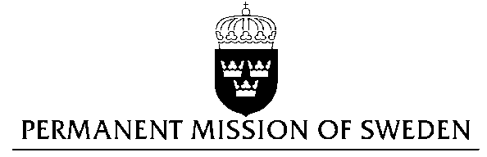
UN Human Rights Council

UPR 28th session

Statement by Sweden in the interactive dialogue on Switzerland

Delivered by Minister Counsellor Karin Bolin
Geneva, 9 November 2017 (speaking time 1.10)

Mr. President,

Sweden wishes to welcome the delegation of Switzerland and extends our thanks for the report and the presentation. Sweden acknowledges the continued work of the Government of Switzerland to fulfil its obligations with regard to human rights and encourages further efforts.

Sweden recommends the Government of Switzerland to:

- adopt an integrated gender mainstreaming strategy, including through the use of gender-budgeting processes, also taking into consideration Sustainable Development Goal 5 of the Agenda 2030.

- adopt legislation which explicitly prohibits corporal punishment of children in all settings, including in the home,

- adopt legislation to eliminate the sterility prerequisite for legal change of gender, in conformity with the European Convention on Human Rights.

Sweden wishes the Government of Switzerland all success in the current review and in implementing the recommendations.

I thank you Mr. President

