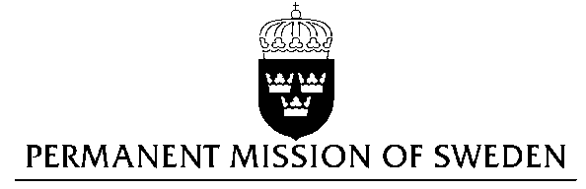
UN Human Rights Council

UPR 28th session

Statement by Sweden in the interactive dialogue on Sri Lanka

Delivered by Ms. Karin Bolin, Minister Counsellor
Geneva, 15th November 2017 (speaking time 1.20)

Thank you Mr President,

Sweden wishes to welcome the delegation of Sri Lanka and extends its thanks for the report and the presentation.

Sweden recommends the Government of Sri Lanka:

- to enact legislation making enforced disappearances a crime under national law in accordance with the Convention for the Protection of All Persons from Enforced Disappearance,

- to amend the Penal Code, particularly Sections 365 and 365A, to decriminalize consensual same-sex conduct as well as displays of affection,

- to end impunity and ensure that perpetrators of incitement to hatred and violence are brought to justice in compliance with international law.

Sweden wishes the Government of Sri Lanka all success in the current review and in implementing the recommendations.

I thank you Mr. President

