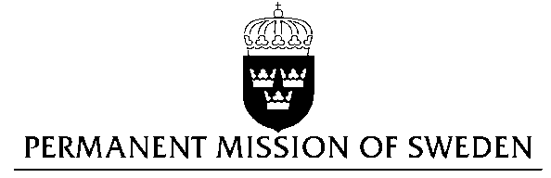
UN Human Rights Council

UPR 28th session

Statement by Sweden in the interactive dialogue on the Republic of Korea

Delivered by Minister Counsellor Karin Bolin
Geneva, 9 November 2017 (speaking time 1.15)

Mr President,

Sweden wishes to welcome the delegation of the Republic of Korea and extends its thanks for the report and the presentation. Sweden acknowledges the continued work of the Government of the Republic of Korea to fulfil its obligations with regard to human rights and encourages further efforts.

Sweden recommends the Government of the Republic of Korea to:

- ratify and implement the remaining four ILO core conventions concerning Freedom of Association and Protection of the Right to Organise; Right to Organise and Collective Bargaining; Forced Labour ; and Abolition of Forced Labour,

- ratify the second Optional Protocol to the International Covenant on Civil and Political Rights, aiming at the abolition of the death penalty,

- include a specific prohibition on discrimination on the basis of sexual orientation in the Anti-discrimination Law.

Sweden wishes the Government of the Republic of Korea all success in the current review and in implementing the recommendations.

I thank you Mr. President

