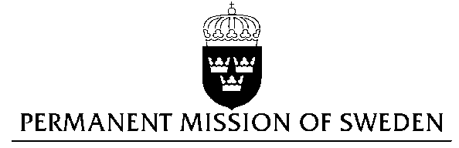
UN Human Rights Council

UPR 28th session

Statement by Sweden in the interactive dialogue on Pakistan

Delivered by Ambassador Veronika Bard
Geneva, 13 November 2017 (speaking time 1.05)

Mr President,

Sweden wishes to welcome the delegation of Pakistan and extends its thanks for the report and the presentation. Sweden recommends the Government of Pakistan to:

- enact legislation on domestic violence in all provinces.

- ensure effective and monitored enforcement of existing federal and provincial legislation related to violence against women.

- prevent impunity for crimes against journalists and media workers.

- provide updated information regarding the judicial status of cases of murdered journalists to the UNESCO Director-General’s Report on the Safety of Journalists and the Danger of Impunity

- reinstate the moratorium on the death penalty, as a first step towards complete abolition and accession to the Second Optional Protocol to the ICCPR.

I thank you Mr President.

