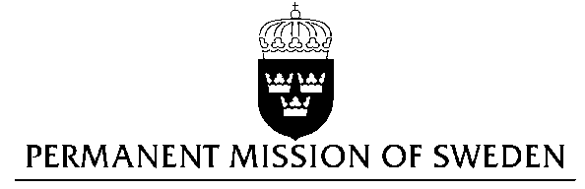
UN Human Rights Council

UPR 28th session

Statement by Sweden in the interactive dialogue on Guatemala

Delivered by Counsellor Anna Envall
Geneva, 8 November 2017 (speaking time 1.50)

Thank you Mr President,

Sweden wishes to welcome the delegation of Guatemala and extends our thanks for the report and the presentation. Sweden acknowledges the continued work of the Government of Guatemala to fulfil its obligations with regard to human rights and encourages further efforts.

Gender-based violence remains a serious problem in Guatemala. Violence against LGBTI persons is frequent. Of particular concern are the high levels of sexual violence and teenage pregnancies. Measures have been taken to strengthen the legal framework and create institutions, such as the specialized court for violence against women. Integration of a human rights and gender perspective in the judgements of the ordinary courts can be noted in some cases. However, challenges remain in terms of prevention, allocation of resources and implementation.

Sweden recommends the Government of Guatemala to:

- take measures to prevent child pregnancies, inter alia by providing access to comprehensive sexuality education and integral sexual and reproductive health services for teenagers,

- fully cooperate with the International Commission Against Impunity in Guatemala in all aspects of its mandate,

- adopt and ensure full implementation of the Public Policy of the Protection of Human Rights Defenders as well as the Protocol for the Public Prosecutors Office on the Investigation of Cases against Human Rights Defenders.

Sweden wishes the Government of Guatemala all success in the current review and in implementing the recommendations.

I thank you Mr. President

