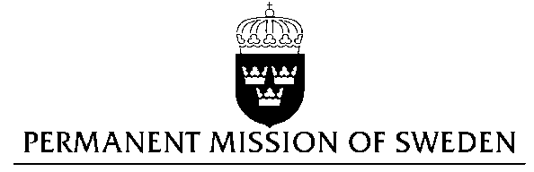
UN Human Rights Council

UPR 28th session

Statement by Sweden in the interactive dialogue on Ghana

Delivered by Minister Counsellor Karin Bolin
Geneva, 7 November 2017 (speaking time 1.15)

Thank you Mr President,

Sweden wishes to welcome the delegation of Ghana and extends our thanks for the report and the presentation. Sweden acknowledges the continued work of the Government of Ghana to fulfil its obligations with regard to human rights and encourages further efforts.

Sweden recommends the Government of Ghana to:

- ratify the second Optional Protocol to the ICCPR, aiming at the abolition of the death penalty,

- adopt a formal moratorium and commute all death sentences to prison terms,

- decriminalize consensual, same-sex sexual acts,

- adopt subnational action plans for strengthening implementation of laws prohibiting harmful practices, including but not limited to: trokosi, female genital mutilation, child, early and forced marriage, widowhood rites and practices related to “witchcraft”

Recommendations on these subjects have been made to the Government of Ghana in previous UPR cycles. Sweden believes that the recommendations are still valid.

Sweden wishes the Government of Ghana all success in the current review and in implementing the recommendations.

I thank you Mr. President

