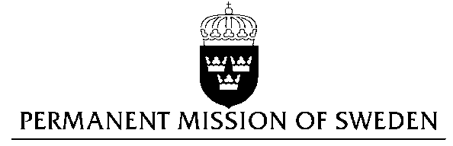
UN Human Rights Council

UPR 28th session

Statement by Sweden in the interactive dialogue on Argentina

Delivered by Minister Counsellor Karin Bolin
Geneva, 6 November 2017 (speaking time 1.30)

Mr President,

Sweden wishes to welcome the delegation of Argentina. Sweden recommends the Government of Argentina to:

- implement the National Strategy for the Prevention, Assistance and Eradication of Violence against women 2017-2019, and to ensure continuation of this work beyond 2019,

- to adopt legislation prohibiting all forms of corporal punishment of children in all settings,

- to take immediate and concrete steps to rectify the deficiencies in Argentinian prisons, detentions centres and police stations such as overcrowding, poor access to health services, insufficient food, bad ventilation, precarious sanitary conditions and squalor,

The background to our recommendations is:

Violence against women remains a major concern in Argentina. The launch of the National Strategy to combat Violence Against Women was a first, positive step. However, question remains on how the strategy shall be pursued beyond 2019.

Argentinian law ensures children the enjoyment of human rights but, as highlighted by the Human Rights Committee, Argentina is lacking a general prohibition of corporal punishment.

The situation in many of Argentina’s prisons, detentions centres and police stations remain incompatible with human dignity of those deprived of their liberty.

I thank you Mr. President

