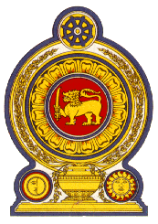
Statement by the Democratic Socialist Republic of Sri Lanka
28th Session of the Universal Periodic Review
Review of Pakistan – 13 November 2017

Mr. President,

Sri Lanka welcomes the Hon. Foreign Minister and the delegation of Pakistan, and appreciates the comprehensive update provided by the delegation, and the national report.
Sri Lanka recognizes the positive developments on promotion and protection of human rights during the period under review, including establishment of a dedicated Ministry of Human Rights and the National Commission on Human Rights in 2015, following the enactment of legislation.
Sri Lanka welcomes Pakistan’s enhanced engagement with the UN Treaty Bodies and the recent ratification of the Optional Protocol to the Convention on the Rights of the Child (CRC) on the involvement of children in armed conflict.
Sri Lanka wishes to make the following recommendations;
- Continue to take step to implement the National Human Rights Action Plan.
- Continue improving maternal and neonatal health services through interventions at national and provincial levels.
- Finalise the National Policy Framework on Human Rights, in consultation with stakeholders.

We wish Pakistan success in its UPR engagement.

Thank you.

