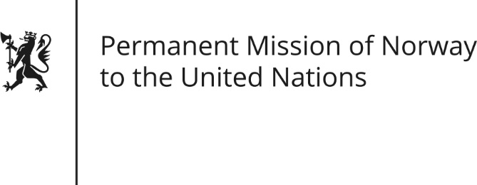

STATEMENT by Marthe Kielland Rossaak

28th Session of the Universal Periodic Review

Zambia

13 November 2017

Check against delivery

Mr President,
(Norway thanks Zambia for submitting its national report.)
(We are pleased to note progress with regards to the right to education and that Zambia since the previous cycle has domesticated the Convention on the Elimination of All Forms of Discrimination Against Women.)
Norway’s primary concerns relate to the deteriorating space for freedom of assembly and speech (since the run-up to last year’s elections), to the rights of the child and to the follow-up of UPR recommendations.
We recommend that Zambia reforms the Public Order Act and that law enforcement agencies are instructed to uphold the Act without political bias.
We further recommend enhanced protection of the rights of the child, including abolishing child labour, combating malnutrition and shielding child perpetrators during detention.
Finally, Norway recommends Zambia to take concrete step towards the abolition of death penalty.

