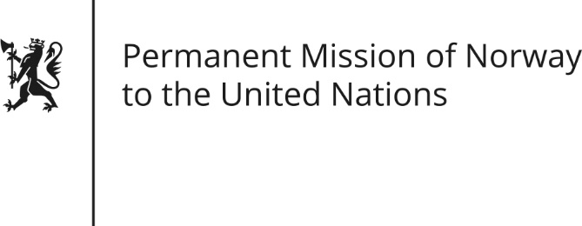

STATEMENT by Senior Advisor Hilde Austad

28th Session of the Universal Periodic Review

Ukraine

15 November 2017

Check against delivery

Mr President,

Norway thanks Ukraine’s delegation for the presentation of their National Report. We commend Ukraine for general progress in legislation promoting human rights.

Norway is deeply concerned about the human rights and humanitarian law violations in eastern Ukraine and the continued support from Russia to the separatists. The use of mines and the placing of military hardware in populated areas continue. We recommend Ukrainian authorities abstain from any practice that could endanger the life of civilians.

A diverse civil society is vital for the development of a healthy democracy. Norway recommends the government adopt legislation that is conducive to the development and safeguarding of today’s strong and vibrant NGO-community in Ukraine.

Finally, Norway recommends Ukraine ratify the Council of Europe Convention on the prevention of violence against women and domestic violence (Istanbul Convention). We welcome the prominent role of Ukrainian women in public life, but there are women tormented by domestic violence. In light of the ongoing conflict, there is an imminent danger that this may be further exacerbated.

Thank you.

