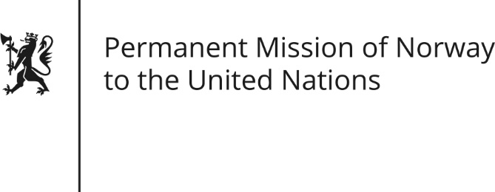

STATEMENT by Ambassador Hans Brattskar

28th Session of the Universal Periodic Review

Switzerland

9 November 2017

Check against delivery

Mr President,
Norway commends Switzerland for progress made during the review period.
We welcome the initiated legislative process to establish a National Human Rights Institution. Having re-established our own NHRI to fully comply with the Paris principles,
Norway recommends establishing an NHRI that is guaranteed broad competences, as well as institutional and financial independence.
In light of the pending constitutional initiative to declare the supremacy of the Swiss constitution over international law,
Norway recommends installing mechanisms to ensure the compatibility of popular initiatives with Switzerland’s human rights commitments.
Thank you.

