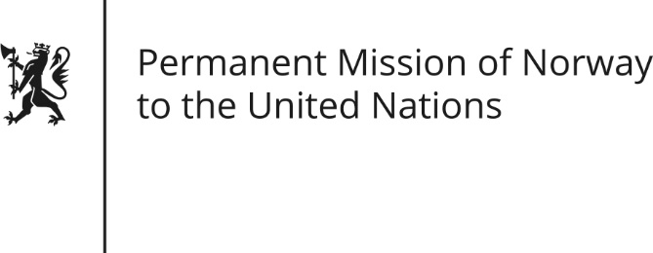

STATEMENT by Ambassador Hans Brattskar

28th Session of the Universal Periodic Review

Sri Lanka

15 November 2017

Check against delivery

Mr President,

Norway welcomes the presentation of the National Report by the delegation of Sri Lanka. We note in particular positive steps towards mainstreaming non-discrimination and equality in the legal framework.

We would like to highlight four areas for improvement:

(Sri Lanka has made provisions for increasing women’s representation in local councils.) We recommend that Sri Lanka pursues sustained policies aimed at the promotion of women’s full and equal participation in decision-making at all levels of government. We also recommend the full incorporation of CEDAW into Sri Lanka’s domestic system.

We recommend that Sri Lanka develops a clear timeline and benchmarks for the full implementation of its commitments in HRC resolution 30/1.

We recommend that Sri Lanka takes concrete measures to abolish the death penalty.

We recommend that Sri Lanka ensures a safe and enabling environment for civil society and human rights defenders.

Thank you.

