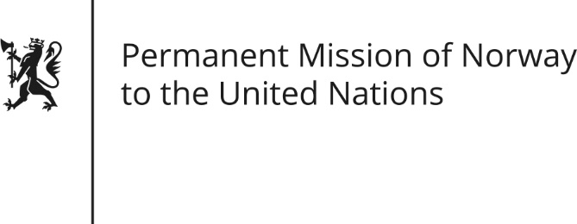

STATEMENT by Senior Advisor Mr Knut Seim

28th Session of the Universal Periodic Review

The Republic of Korea

9 November 2017

Check against delivery
Thank you Mister President,
Norway welcomes the delegation from the Republic of Korea and the presentation of their report.
Norway congratulates the Republic of Korea on its efforts to implement accepted UPR recommendations. In particular we welcome impressive achievements in the area of the right to assembly.
We recommend that the Republic of Korea adopts a comprehensive Anti-Discrimination Act to protect the human rights of LGBTI individuals and other marginalized groups.
Norway appreciates that death penalty has been de facto abolished since 1997. We recommend that the Republic of Korea move on to de jure abolition of the death penalty.
Norway welcomes the improvements in the situation for single-parent families, but we remain concerned about discrimination faced by single mothers in particular. We recommend improved enforcement of the Single-Parent Family Support Act.
Thank you.

