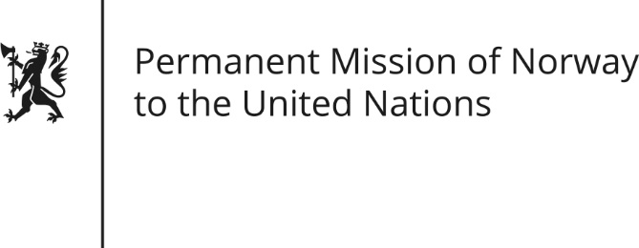

STATEMENT by Director Haakon Gram-Johannessen

28th Session of the Universal Periodic Review

Peru

8 November 2017

Check against delivery
Mr. President,
Norway commends Peru’s efforts to protect and promote human rights, including measures taken to reduce poverty, strengthen the rights of women and reduce social inequality.
Norway recommends that Peru take actions to strengthen the implementation of ILO-Convention 169, together with the employment of effective measures to protect the territory of isolated indigenous peoples. This includes revising overlapping land rights to further progress the assigning of territory to indigenous peoples in order to prevent land conflicts.
Norway recommends that Peru intensifies its efforts to protect environmental, indigenous and land rights defenders, in line with the Declaration on Human Rights Defenders, especially regarding the use of force and firearms at public assemblies and protests.
(To promote women’s rights, we recommend Peru to take steps in accordance with the recommendations from the Human Rights Council’s working group on the issues of discrimination against women in law and practice).
Thank you.

