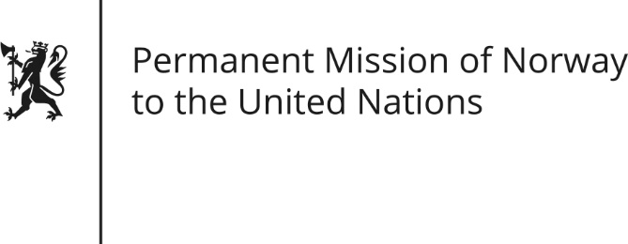

STATEMENT

Universal Periodic Review 28th Session. Review of Pakistan.

13 November 2017

Norway thanks the delegation of Pakistan for their presentation.

Norway welcomes Pakistan’s enactment of domestic legislation seeking to enshrine fundamental human rights and the establishment of the National Commission for Human Rights.

Norway recommends that Pakistan reinstate the moratorium on the death penalty with a view to abolishing it.

Religious minorities, journalists and human rights defenders, and in particular women among them, are subjected regularly to violence, despite constitutional guarantees. Norway recommends that Pakistan investigate all reports of violence against religious minorities and bring those responsible to justice.

Norway recommends that Pakistan investigate all reports of attacks on journalists and human rights defenders and bring perpetrators to justice.

A reported 25 million children lack access to education in Pakistan. Norway recommends that Pakistan implement federal and provincial laws on the right to education to ensure universal access.

Thank you.

