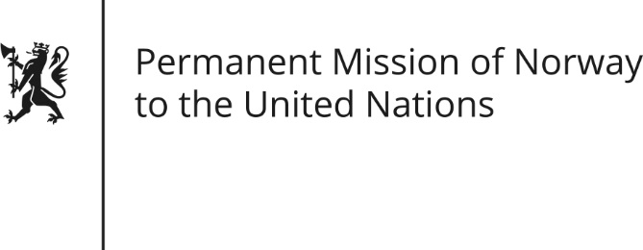

STATEMENT by Director Haakon Gram-Johannessen

28th Session of the Universal Periodic Review

Guatemala

8 November 2017

Check against delivery
UPR Guatemala – 28th session November 2018

Mr/Mdm Chair
Norway welcomes the delegation from Guatemala and the presentation of their report.

Norway commends Guatemala on the progress made by the Public Prosecutor, with support of CICIG, to advance justice and reduce impunity.

We recommend Guatemala to continue the good cooperation with the OHCHR at country level, which has generated concrete results including the development of new jurisprudence in the field of human rights. Moreover, we recommend Guatemala to finalize and implement a national action plan to follow-up the UN Guiding Principles on Business and Human Rights.

Norway is concerned about the increased levels of poverty in Guatemala, which is largely concentrated in the provinces with the highest degree of indigenous population. (The State should approach these issues as structural problems that need clear and coherent strategies so that all people can enjoy secure access to adequate food.)

Norway therefore recommends that Guatemala develop and implement comprehensive and efficient policies to fight poverty and in particular chronic and acute malnutrition.
Thank you.

