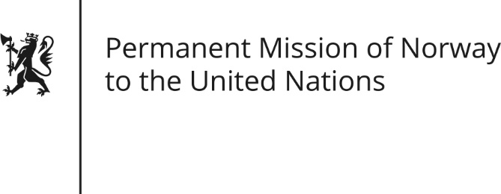

STATEMENT by First Secretary Paul Bjørdal

28th Session of the Universal Periodic Review

Ghana

7 November 2017

Check against delivery

Mr/Mdm Chair,
We welcome the delegation of Ghana and the presentation of their national report.

Norway commends Ghana for the progress made and positive actions taken up since the second UPR cycle in 2012. We welcome the ratification of the Optional Protcol to the Un Convention against Torture.

Norway recommends that Ghana take immediate measures to introduce a formal moratorium on executions and take concrete steps toward the total abolition of the death penalty.

Norway is concerned about high prevalence of domestic violence and rape, and recommends that legislation on domestic violence be fully implemented.
Norway recommends that laws protecting girls and women from Female Genital Mutilation be strengthened through dedicated programs and mechanisms, and monitored closely.

Norway recommends that Ghana prioritize and fund information campaigns for non-discrimination and universal access for the LGBT group of Ghana.

Lastly, Norway recommends anti-trafficking legislation to be adopted and implemented.

Thank you.

