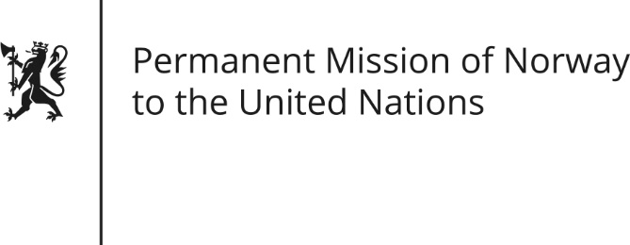

STATEMENT by First Secretary Paul Bjørdal

28th Session of the Universal Periodic Review

Czech Republic

6 November 2017

Check against delivery

Mr/Mdm Chair,
Norway thanks the Czech delegation for presenting its national report.

We commend the amendment to the Education Act No 82/2015 on special educational needs, which came into effect 9/2016. Norway recommends continued focus and dedicated programs on inclusive education for all, also with regard to ending segregation of Roma children.

(We support the work of the Czech Public Defender of Rights (Ombudsman)). To ensure the rights of children, as a vulnerable group, we recommend establishing a separate Ombud particularly dedicated to the rights of children. (To safeguard the well-being of children, Norway has had an Ombudsman for Children since 1981).

We recognize efforts made to ensure gender equality, and support the Amendment to the Education Act No 178/2016 on preschool education, which calls for municipalities to guarantee childcare for all children over 2 years by September 2020. Norway recommends the implementation of this act and other measures to strengthen gender equality.
Thank you.

