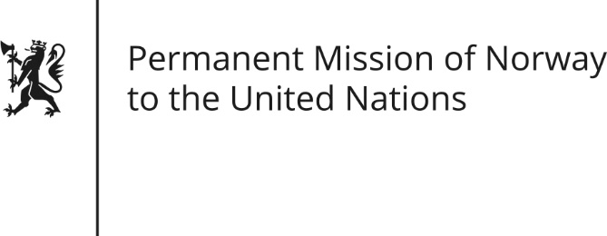

STATEMENT by Advisor Fredrik Brogeland Laache

28th Session of the Universal Periodic Review

Argentina

6 November 2017

Check against delivery

Mr/Mdm Chair,
Norway welcomes the Argentinian delegation and thanks Argentina for their presentation of the report.
Gender-based violence remains a serious problem in Argentina. Norway recommends that Argentina allocate sufficient resources to ensure effective implementation of the National plan to combat violence against women.
(The high number of unsafe abortions in Argentina threatens women’s universal right to life and health.) We recommend that Argentina take steps to ensure that no woman or girl is subject to criminal sanctions for abortion.
(A significant gap remains between the laws to protect the rights of Indigenous Peoples and their implementation.) Norway recommends that Argentina take further steps to ensure Indigenous Peoples’ right to consultation, to obtain their free, prior and informed consent before proceeding with legal and administrative measures that may affect their rights.
(Finally, Norway would like to commend Argentina for recently passing a law on Access to Public Information, as this was one of our recommendations in 2012.)

Thank you.

