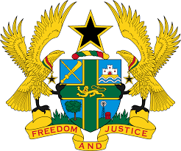
28TH SESSION OF THE UPR WORKING GROUP
6TH – 17TH NOVEMBER, 2017

REPORT OF THE WORKING GROUP ON THE UNIVERSAL
PERIODIC REVIEW OF ARGENTINA

STATEMENT BY GHANA DELIVERED BY MISS RHEENA ARTHUR,
INTERN, ON MONDAY 6TH NOVEMBER, 2017

Mr. Vice President,

Ghana extends a warm welcome to the delegation of Argentina to their third UPR.

My delegation lauds the actions taken by Argentina to implement a significant number of recommendations it accepted during the second review, including, inter alia, the ratification of the Optional Protocol to the Convention on the Rights of the Child in 2015, the Convention on the Reduction of Statelessness, and the ILO Convention No. 189 in 2014.

Ghana commends Argentina for committing to reduce the number of unregistered births within indigenous communities through the introduction of the birth registration system and mobile documentation units.

My delegation recommends to Argentina the following:

- Take steps to guarantee the effective implementation of the national
system to prevent torture, including through encouraging Provincial States
to establish by law independent and adequately resourced local
preventive mechanisms in compliance with OP-CAT requirements.

ii. Take concrete steps to implement fundamental safeguards in police
custody, and prohibit the use of police stations as places for long-term
detention.

Ghana wishes Argentina every success with the review.

I thank you.

