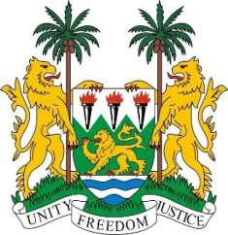
SIERRA LEONE
28th Session of the UPR

ZAMBIA

13 November 2017

Mr Vice-President,

Sierra Leone warmly welcomes the distinguished delegation from the Zambia to this UPR session and thanks them for today’s presentation.

Sierra Leone congratulates Zambia for the candidness of its national report which provides statistical evidence to demonstrate the status of implementation of its human rights obligations, and which illustrates clearly the areas for improvement.

My delegation commends the Government of Zambia for the progressive steps taken since their last review cycle 5 years ago including, among others, the implementation of their Seventh National Development Plan (2017-2021), the enactment of the Gender Equity and Equality Act (2017), the Refugee Act (2015) and the Higher Education Loans and Scholarship Act (2016). Sierra Leone applauds efforts to address trafficking which has led to a marked reduction of cases.

Nonetheless, Sierra Leone would like to encourage Zambia to increase the representation of women in decision-making and leadership positions and to revise and adopt comprehensive nutrition policies in order to effectively address its national malnutrition challenges.

Sierra Leone has the following recommendations:

- Intensify efforts, including seeking technical assistance, wherever required, to meet its human rights targets.
- Modify its national and customary laws in order to prevent child, early and forced marriage.
- Strengthen national policies to ensure that persons with albinism are fully protected from attacks and implement awareness-raising programmes which also promote their social integration in rural areas.
- Raise the minimum age of criminal responsibility above 8.

To conclude, Sierra Leone wishes Zambia a successful completion of its national review.

Thank you, Mr Vice-President.

