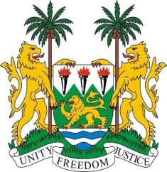
SIERRA LEONE
28th Session of the UPR

UKRAINE

15 November 2017

Mr Vice-President,

Sierra Leone welcomes the distinguished delegation from Ukraine to this UPR review cycle and thanks them for today’s presentation.

My delegation notes that despite the complex challenges faced by Ukraine due to the conflict in the east which has led to the internal displacement of 1.6 million people, the government has undertaken various progressive measures including its national health system reforms in 2016 and its constitutional reform in 2016.

We note that its Ombudsperson’s office has been re-accredited with an “A” status.

My delegation further notes the adoption of a national action plan on the implementation of the CRC (2017 – 2022) and on trafficking (2016 – 2020), as well as the Human Rights Action Plan.

Sierra Leone would however encourage Ukraine to develop strategies to more effectively investigate and prosecute cases of sexual violence. In particular, the government should amend its Criminal Code and bring it in line with international standards and ensure that victims receive comprehensive medical treatment and psychological support.

Recommendations:

- Ratify and accede to the International Convention on the Protection of the Rights of All Migrant Workers and Members of Their Families (ICRMW).
- Expedite the ratification of the Istanbul Convention and criminalize domestic violence in order to provide more comprehensive coverage for combating violence against women and girls.
- Conduct public campaigns to promote cultural diversity and tolerance towards minorities, victims of hate crimes.

Sierra Leone wishes Ukraine every success in completing its third review cycle.

Thank you, Mr Vice-President.

