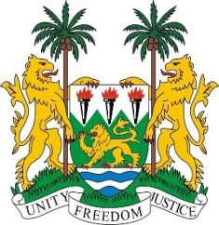
SIERRA LEONE
28th Session of the UPR

SWITZERLAND

9 November 2017

Mr President,

Sierra Leone welcomes the distinguished delegation of Switzerland and thanks them for their comprehensive presentation.

My delegation commends Switzerland for establishing the National Programme to Prevent and Fight Poverty 2014-2018, the National Action Plan 2017-2020, and for adopting its 2016-2019 Human Rights Strategy to ensure that its human rights institutions and mechanisms are further strengthened.

My delegation notes that Switzerland has consistently contributed to the work of the OHCHR and since 2002, has established a standing invitation to all special procedures mandate holders.

Recommendations:

- Expedite the establishment of an independent national human rights institution in line with the Paris Principles.
- Ensure that asylum procedures fully respect the best interests and special needs of unaccompanied children.
- Expedite the ratification of the Istanbul Convention preventing and combating violence against women and domestic violence.
- Adopt a comprehensive anti-discrimination legislation to address all forms of discrimination, hate speech and negative stereotypes.

While acknowledging the generous assistance provided by the Swiss government, Sierra Leone would encourage Switzerland to raise its development assistance to 0.7 per cent of its GDP.

To conclude, Sierra Leone wishes Switzerland full success in completing their third review.

Thank you, Mr President.

