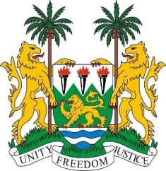
SIERRA LEONE
28th Session of the UPR

REPUBLIC OF KOREA

9 November 2017

Mr President,

Sierra Leone welcomes the distinguished delegation of the Republic of Korea and thanks them for today’s presentation and for their very detailed report.

My delegation notes that the Republic of North Korea has contributed annually to the OHCHR and the government intends to increase its Official Development Assistance (ODA) assistance to developing countries by an additional 0.2 percent by 2020.

Sierra Leone would encourage the Government of the Republic of Korea to promote social integration policies and cultural exchanges, as well as strengthening mechanisms for preventing and addressing reports of xenophobic discourse against migrants, foreigners and multicultural families.

Recommendations:

- Ratify the International Convention on the Protection of the Rights of All Migrant Workers and Members of their Families (ICRMW) and the International Convention for the Protection of all Persons from Enforces Disappearance (ICPPED).
- Implement policies and measures which comprehensively address hate speech through legislative and institutional frameworks.
- Adopt a comprehensive strategy to prevent gender-based violence and thoroughly investigate and prosecute incidents of domestic violence perpetuated within migrant populations.
- Establish a comprehensive national birth registration system for foreign nationals to ensure the births of their children are registered.

In conclusion, Sierra Leone wishes the Republic of Korea every success in completing this UPR cycle.

Thank you, Mr President.

