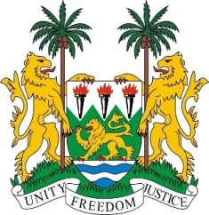
SIERRA LEONE
28th Session of the UPR

PERU

8 November 2017
Mr Vice-President,

Sierra Leone warmly welcomes the Peruvian delegation to this UPR session and thanks them for today’s presentation.

My delegation notes that Peru has consistently contributed to the OHCHR since 2012. We commend the measures taken to promote and protect human rights through the various National Human Right Plans and the National Operation to Combat Racism.

Furthermore, it is encouraging to note the adoption in 2016 of the National Plan for the Development of the Afro-Peruvian Population 2016-2020, with the objective of guaranteeing the rights to equality and non-discrimination of Afro-Peruvians, as well as the efforts to provide them with educational assistance. Also noteworthy is the work of the National Afro-Peruvian Council, the working group on policies for Afro-Peruvians, the inclusion of a question on ethnic origin in the 2017 census, and the first conviction for the crime of racial discrimination. However, my delegation notes with concern that access to justice, stereotyping and racist discourse continue to present challenges.
My delegation notes Peru’s de facto abolition of the death penalty, and that in 2016, the government adopted the Trafficking in Persons and Smuggling of Migrants Act, as well as a new national plan to combat trafficking in persons (2017-2021).

Recommendations:

- Strengthen policies and measures to address incidents of discrimination perpetuated against indigenous and Afro-Peruvian women, especially in relation to access to education, employment and healthcare services.
- Implement measures to mitigate the environmental impact of the exploitation of oil and gas and oil spills in the territories of indigenous peoples, on their communities and give further attention to environmental degradation.
- Ensure that asylum seekers have equal access to universal healthcare services.

To conclude, Sierra Leone wishes Peru every success during their third review cycle.

Thank you, Mr Vice-President.

