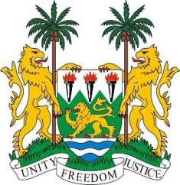
SIERRA LEONE

28th Session of the UPR

PAKISTAN

13 November 2017

Mr President,

Sierra Leone welcomes the distinguished delegation from Pakistan and thanks them for their presentation. We note that Pakistan has consistently contributed to the OHCHR since 2012.

My delegation also notes the establishment of the National Action Plan on Human Rights of 2016, as well as the establishment of the National Commission on Human Rights (NCHR) which has been functional since 2015. We applaud the government for recently amending its laws to ensure that the 4.4 million people living within the Federally Administered Tribal Areas (FATA) will enjoy the same fundamental human rights enshrined within the Pakistan constitution and legal frameworks.

Recommendations:

- Accede to and ratify the ICPPED.

- Update national laws to cover all forms of trafficking, eliminate cross-border trafficking in persons and forced marriage.

- Ensure that minority groups including Scheduled Castes are not discriminated against in education, health care, employment and other basic services and that perpetrators of hate crimes against them face the full course of the law.

In conclusion, Sierra Leone wishes Pakistan a successful conclusion of their UPR.

Thank you, Mr President.

