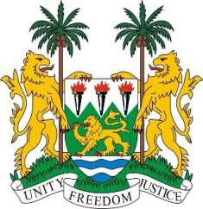
SIERRA LEONE
28th Session of the UP

GUATEMALA

8 November 2017
Mr President,

My delegation welcomes the distinguished delegation of Guatemala to this third review cycle and thanks them for today’s presentation. We applaud the inclusive process involving civil society which was included in the preparation for the UPR review.

Sierra Leone commends Guatemala for the establishment of the National Development Plan (K‵atun “Our Guatemala 2032”) and the national prison reform policy which was launched in 2015.

The efforts of the Government of Guatemala to tackle malnutrition and ensure better access to food through its National Strategy to Prevent Chronic Malnutrition 2016-2020 and the Zero Hunger Pact initiative are commendable.

Sierra Leone makes the following recommendations:

- Ratify the International Convention for the Protection of All Persons from Enforced Disappearances (ICPPED).
- Expedite the implementation of the Public Policy for Coexistence and Elimination of Racism and Racial Discrimination.
- Put in place effective measures and policies to address discrimination against indigenous peoples.
- Strengthen the framework of the National Office for the Prevention of Torture to ensure it is fully functional and able to investigate all reported cases.
- Ensure that thorough and impartial investigations are carried out on allegations of attacks against human rights defenders.

Sierra Leone would like to request the delegation to provide information on the steps Guatemala has taken in addressing its Afro-Guatemalans population in the context of the U.N. Decade on People of African Descent.

To conclude, Sierra Leone wishes Guatemala a successful completion of their national review.

Thank you, Mr President.

