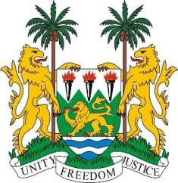
SIERRA LEONE
28th Session of the UPR

GHANA

7 November 2017
Mr President,

My delegation warmly welcomes the distinguished delegation from Ghana to this UPR session and thanks them for today’s presentation.

Sierra Leone applauds the efforts by Ghana to develop a National Human Rights Action Plan (NHRAP) to take into account the United Nations Development Agenda 2030. The government should also be commended for developing a national action plan on human trafficking, as well as another to end statelessness.

It is equally noteworthy that Ghana has achieved the MDG on universal primary education and providing quality education remains a national priority. Furthermore, the government established the End Child Marriage Project in 2016 and my delegation is encouraged to note that Ghana is currently implementing a three-year initiative aimed at eliminating child, early and forced marriage.

Recommendations:

- Ratify the ICPPED.
- Establish measures and policies to address the stigmatisation of persons with albinism and ensure they are effectively protected against discrimination.
- Strengthen legislation and establish clear guidelines and measures to prevent child exploitation and their commercial sexual exploitation.

To conclude, Sierra Leone wishes Ghana a successful completion of their national review.

Thank you, Mr President.

