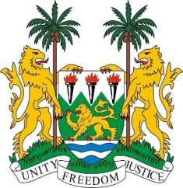
SIERRA LEONE
28th Session of the UPR

GABON

7 November 2017

Mr President,

My delegation warmly welcomes the distinguished delegation from Gabon and thanks them for their presentation today.

Sierra Leone commends the government for the ratification of the Optional Protocol to the Convention on the Rights of Persons with Disabilities and the ongoing efforts to ratify the Optional Protocol to the International Covenant on Economic, Social and Cultural Rights.

In addition, we note with interest that their parliament is currently considering amending the Criminal Code to incorporate penalties for domestic violence and trafficking in persons. My delegation commends the establishment of legislation aimed at defining and eliminating child, early marriage and gender-based violence and encourages efforts aimed at strengthening their implementation.

Furthermore, Sierra Leone applauds the efforts being taken to ensure the fulfilment of economic and social rights in education, health and poverty eradication.

Recommendations:

- Ratify the ICRMW.
- Provide free legal aid to women without sufficient means in order to facilitate their access to justice.
- Adopt laws to combat ritual crimes, appropriately punish the instigators and perpetrators of such offences, and put in place a comprehensive strategy to eliminate them.
- Ensure indigenous people’s participation in decision-making at all levels, and in all matters affecting them, including conservation efforts.

Finally, Sierra Leone wishes Gabon every success in this new review cycle.

Thank you, Mr President.

