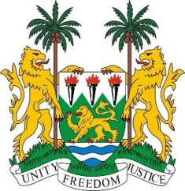
SIERRA LEONE
28th Session of the UPR

CZECHIA

6 November 2017
Mr President,

My delegation welcomes the distinguished delegation from the Czech Republic to this UPR session and thanks them for their presentation. Sierra Leone also thanks Czechia for its contributions to OHCHR since 2012.

We note the adoption of the Roma Integration Strategy 2015–2020 - which aims to ensure the promotion and protection of rights and freedoms of the Roma community, and encourages the government to intensify its efforts for its implementation. Other commendable steps include the establishment of the Inclusive Education Action Plan (2016 – 2018), the establishment of the National Plan on Promoting Equal Opportunities for Persons with Disabilities 2015-2020, and the National Strategy to Protect Children’s Rights 2012 – 2018. While the creation of a national strategy for combatting trafficking in persons is commendable, more effort should be dedicated to standardizing identification and protection measures for victims of trafficking requiring international protection.

My delegation would encourage the Czech Republic to expedite efforts to ratify the Istanbul Convention and to adopt further strategies to quell hate speech and Islamophobia, while also strengthening policies aimed at investigating and criminalising racist hate speech by all, including public officials and politicians.

Recommendations:

- Amend the Public Defender of Rights Act to ensure that it is in line with the Paris Principles.
- Review its national laws and practices to end the detention of all migrant children.
- Revise the Act on the Residence of Foreign Nationals so that migrants and refugees do not pay the costs of their detention.
- Undertake legislative amendments to ensure migrant women and girls have equal access as nationals to public health care services.
- Take steps to increase its Overseas Development Assistance to 0.7 per cent of GDP.

In conclusion, Sierra Leone wishes Czechia every success in this new review cycle.

Thank you, Mr President.

