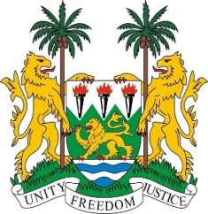
SIERRA LEONE
28th Session of the UPR

BENIN

10 November 2017

Mr Vice-President,

Sierra Leone warmly welcomes the distinguished delegation from Benin to this UPR session and thanks them for today’s presentation.

My delegation applauds the adoption since the last review of a number of Codes to bring domestic law into line with international standards, as well as the various steps taken to address and improve human rights standards nationally. Noteworthy measures include the adoption of the Plan of Action against Racism, Racial Discrimination, Xenophobia and Related Intolerance of 2014, and the establishment in 2015 of the Code for the Rights of the Child and an action plan for its implementation.

Sierra Leone also commends Benin on hosting an African symposium for human rights defenders which took place earlier this year, and applauds the establishment of the Government Programme of Action of 2016-2020 which aims to strengthen democracy and good governance, promote the structural transformation of the economy and improve the living conditions of its population.

Sierra Leone makes the following recommendations:

- Expedite the functionality of its National Human Rights Institution.
- Seek technical assistance to address food security challenges in order to mitigate the negative effects of malnutrition and poverty.
- Develop a strategic framework for the comprehensive protection of children as regards trafficking and sexual exploitation.
- Strengthen literary programmes for women and girls living in rural communities.

In conclusion, Sierra Leone wishes Benin a successful completion of their third review cycle.

Thank you, Mr Vice-President.

