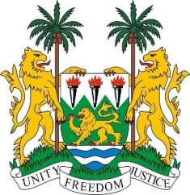
SIERRA LEONE

28th Session of the UPR

ARGENTINA

6 November 2017
Mr Vice-President,

My delegation welcomes the distinguished delegation from Argentina and thanks them for today’s presentation. Sierra Leone notes that Argentina made annual contributions to the OHCHR from the period of 2012-2016.

My delegation notes the steps that have been taken to map discrimination across Argentina and encourages Argentina to take concrete action on the basis of the latest map to address discrimination, wherever it occurs in relation to people of African Descent, minority groups and migrants.

Sierra Leone commends the establishment of a National Plan of Action for the Prevention, Assistance and Eradication of Violence against Women of 2017-2019, which encouragingly, offers comprehensive protection and is complemented by the “Victims against Violence” Programme and the national campaign against child sexual abuse which was launched in November last year.

Recommendations:

- Strengthen the Federal Council to combat human trafficking and exploitation and put in place a national trafficking plan.

- Take steps to address persistent structural discrimination against indigenous peoples and people of African descent, including awareness-raising and the establishment of quantitative measures promoting their participation at the highest level and in decision-making positions.

- Investigate and criminalize cases of xenophobic and stigmatizing discourse expressed by public officials and politicians.

- Adopt a national action plan to end child sexual exploitation.

To conclude, Sierra Leone wishes Argentina every success in this third review cycle.

Thank you, Mr Vice-President.

