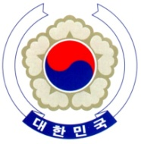

PERMANENT MISSION OF THE REPUBLIC OF KOREA
GENEVA

Universal Periodic Review – Guatemala <Check against delivery>
Geneva, 8 November 2017

Statement of the Republic of Korea

Thank you, Mr. President,

My delegation welcomes the delegation of Guatemala, and the comprehensive presentation on its national efforts to promote and protect human rights.

The Government of the Republic of Korea especially commends the Guatemalan Government’s active role in increasing access to public education to all its people, and the interest in providing public health services. Also, we welcome the progress made so far in judiciary reform.

In this light, the Republic of Korea would like to provide the following recommendations to Guatemala:

- To initiate timely, independent, impartial and effective investigations into threats and attacks against human rights defenders, particularly indigenous defenders, to ensure their effective protection;

- To continue with its efforts to strengthen the effectiveness and independence of the justice system;

- To increase resource allocation and accessibility to public health services

We hope these recommendations contribute to Guatemala’s continued efforts to promote and protect human rights.

Thank you, Mr. President. /END/

