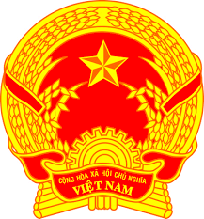

**Statement of the Socialist Republic of Viet Nam**

*48th Session of the UPR Working Group  
Review of Slovenia*

*(Geneva, 28 January 2025)*

*Mister Vice President,*

Viet Nam warmly welcomes the delegation of Slovenia and appreciates its national UPR report.

We commend Slovenia for its continued commitment to human rights, reflected in its progressive policies to combat discrimination, enhance social equality, and address environmental challenges through the Climate Change Act.

In the spirit of constructive dialogue, Viet Nam would like to make the following recommendations:

1. Strengthen efforts to address housing challenges by increasing the availability of affordable public rental housing, particularly for low-income families and other vulnerable groups, to ensure adequate living conditions for all.

2. Further strengthen measures to combat domestic violence by enhancing public awareness campaigns and improving victim support services.

We wish Slovenia a successful UPR cycle.

*Thank you, Mister Vice President.*

***123 words***

***Time: 1 minute 15 seconds***